# IT 140 Project One

## Instructions

Fill out the sections below. Be sure to remove the bracketed text before submitting your Design Document.

Kevin Bergeron

## Storyboard (Description and Map)

Science fiction setting, takes place on a space ship.

You are part of a crew of astronauts on a long distance space vessel on its way to a far away system. In its infinite wisdom, the computer has decided to wake you and only you of your 6 crewmates from cryosleep. After recovering, the ship’s computer tells you there is an unwanted presence in the ship’s core and you need to purge it. You have no means of defense, so the computer instructs you to gather some of the crew’s effects to make a weapon to fight the alien that is nesting in the core. The computer instructs you to find:

* The captain’s personal handheld cooling rod (fan)
* The mechanic’s foam sprayer (for external repairs)
* The doctor’s laser scalpel (for emergency surgery)
* The pilot’s bottle of whiskey (for downtime)
* The navigator’s hand sanitizer bottles (for his OCD)
* The engineer’s duct tape (for fixing anything)

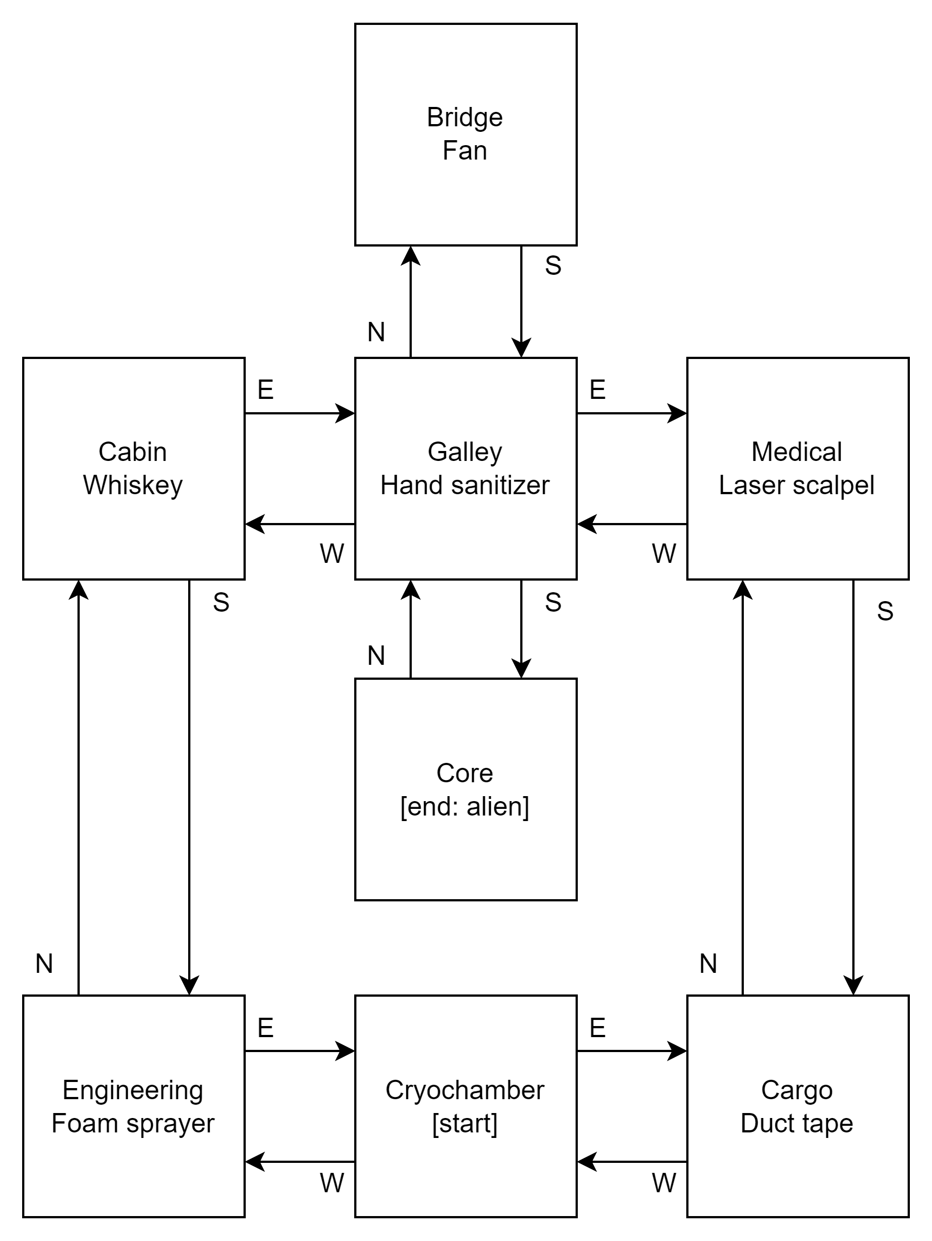

**Flowchart for Code to “Move Between Rooms”**

The following is only for when the user inputs ‘N’, ‘E’, ‘S’, ‘W’ for movement between rooms. This is a function on its own to be called when the user inputs a valid NESW option.

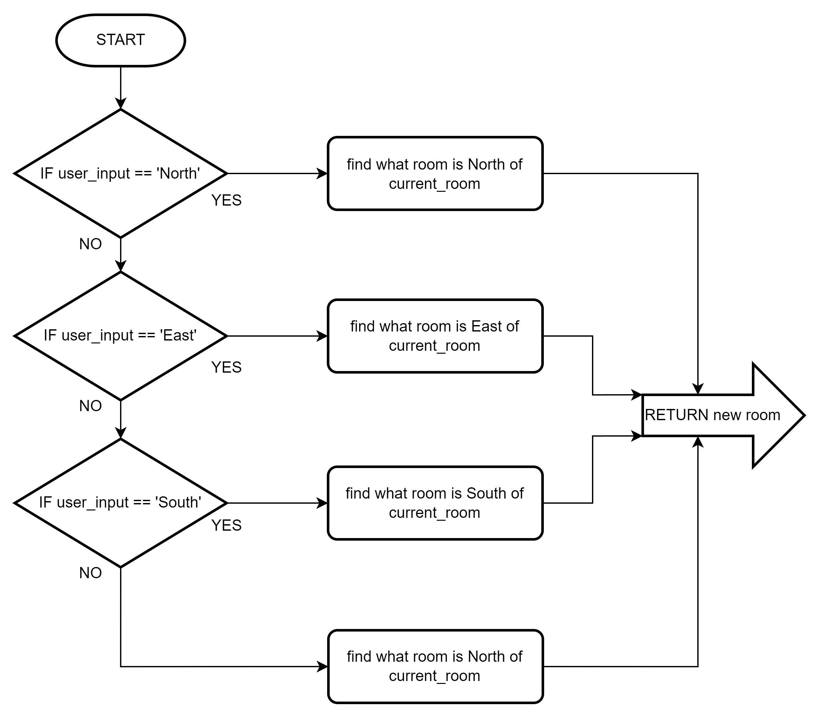

## Pseudocode or Flowchart for Code to “Get an Item”

The below is only for when a user inputs ‘P’. This is a function of its own for when the user inputs P:

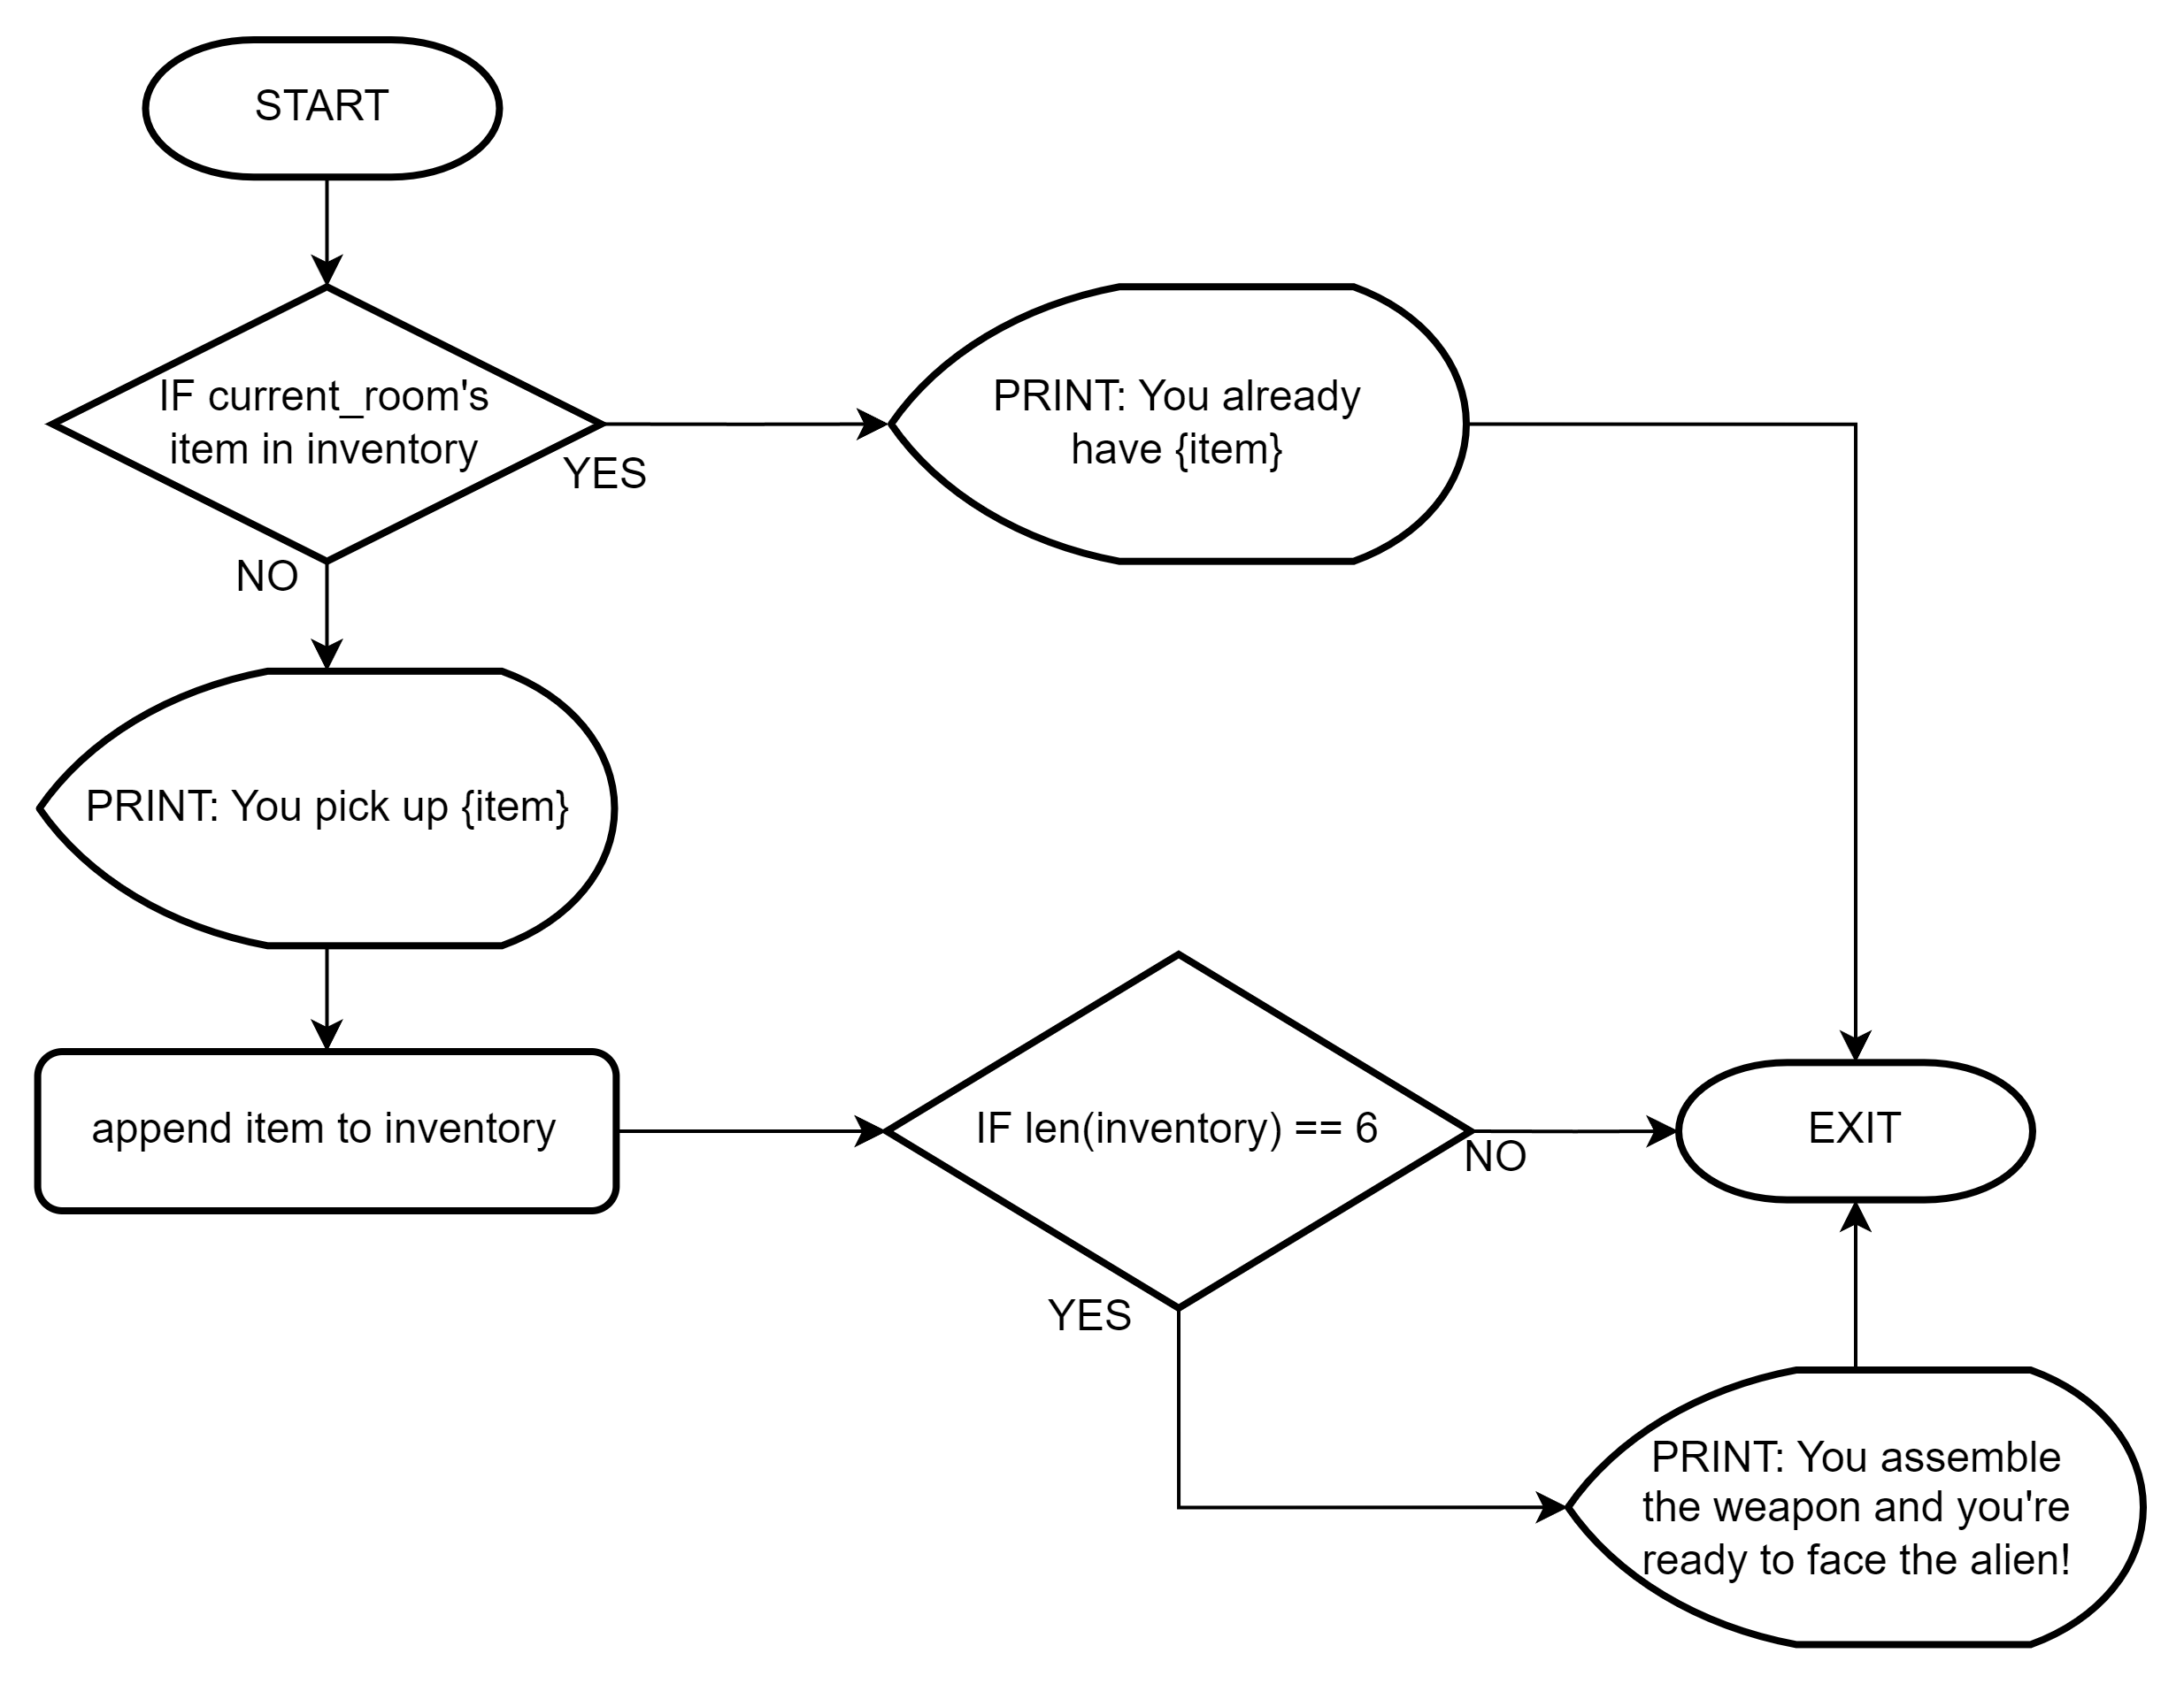

**Flowchart for Code to include PICKUP and MOVE commands:**

Includes start, finish, and all input options (note the empty circles are connector points to improve visibility of flow – multiple paths go in but only one goes out):

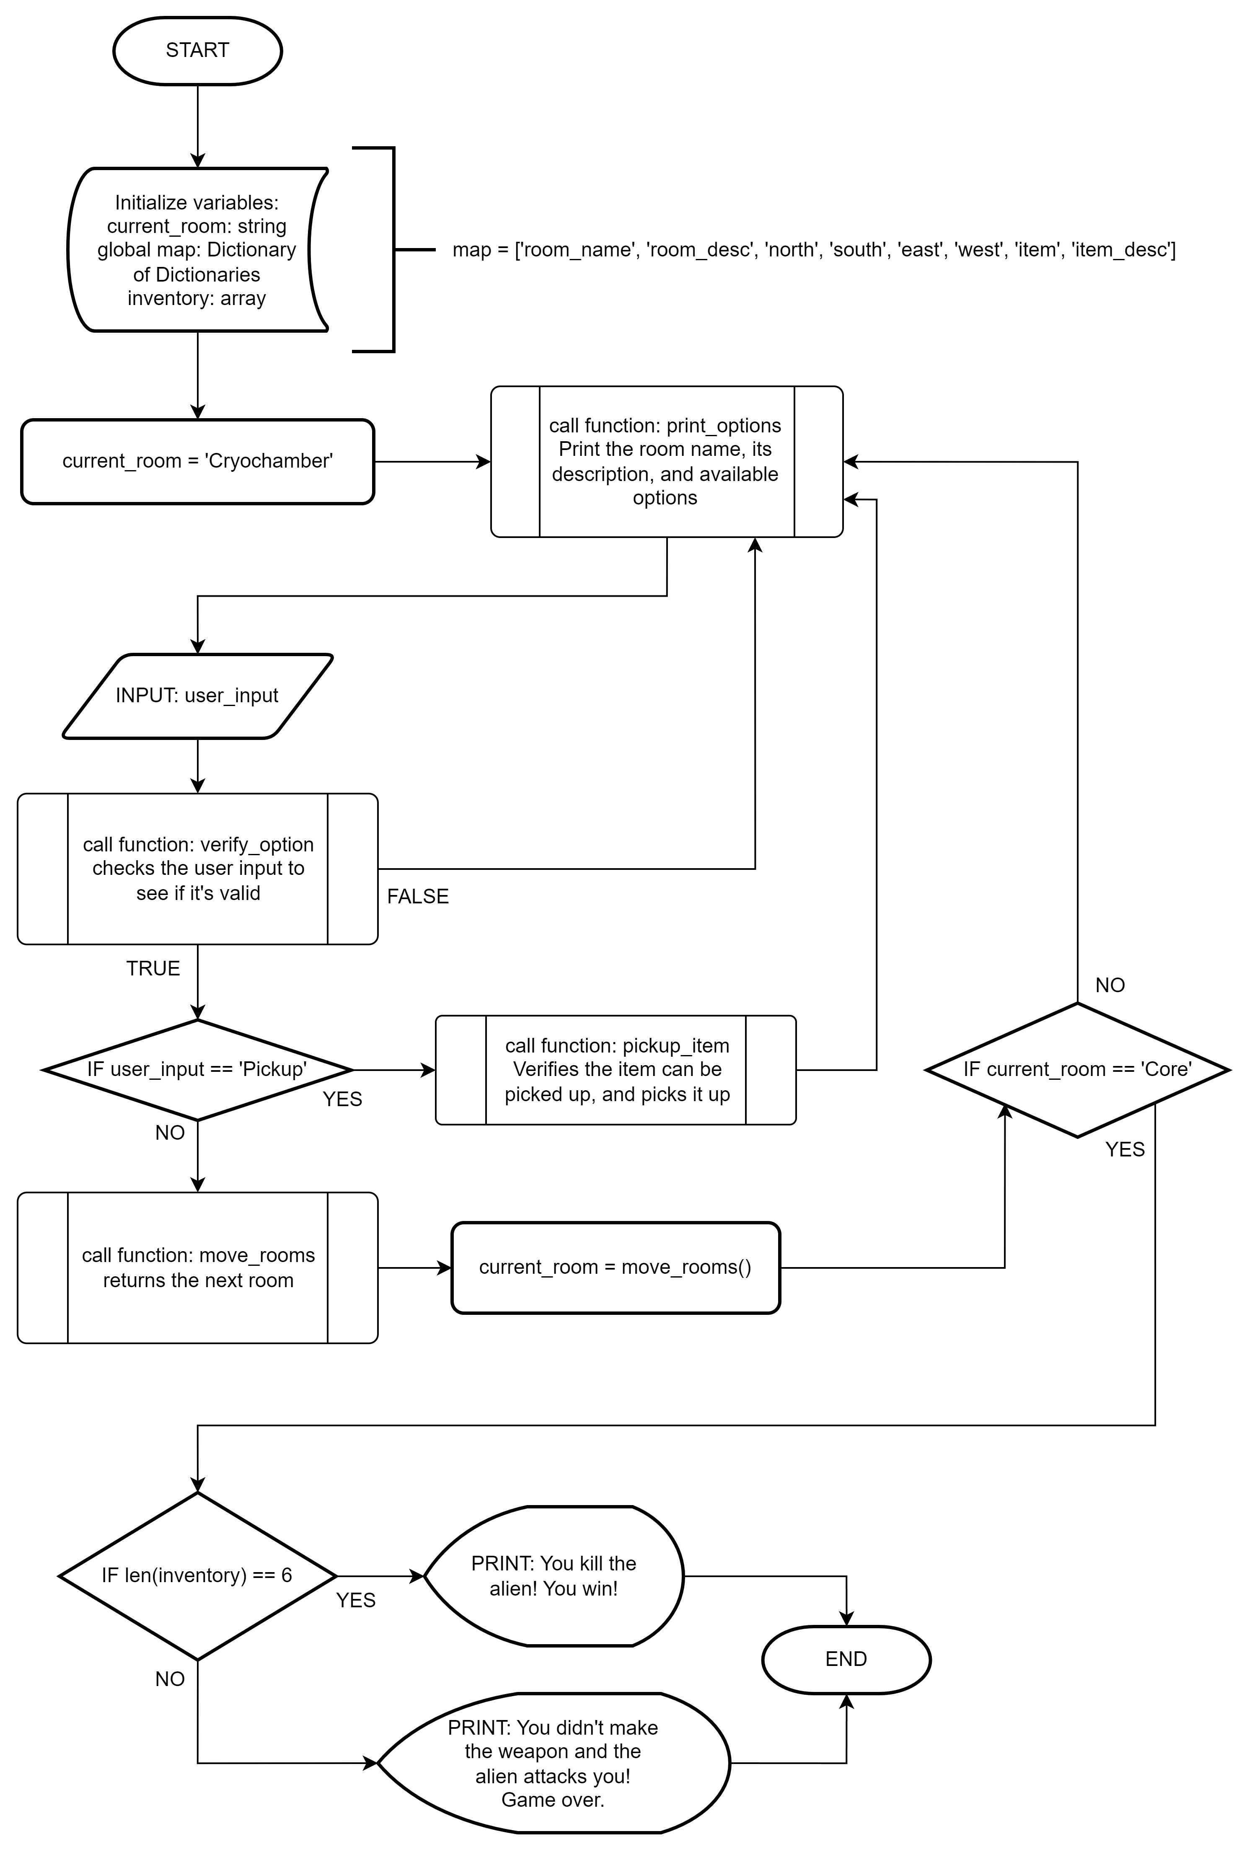

The below are 4 functions required:

